1.Extract data from the given SalaryGender CSV file and store the data from each column in a separate NumPy array

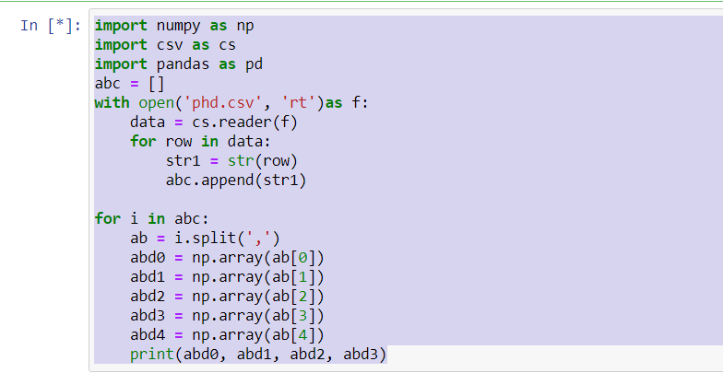

2. Find: 1. The number of men with a PhD

2. The number of women with a PhD

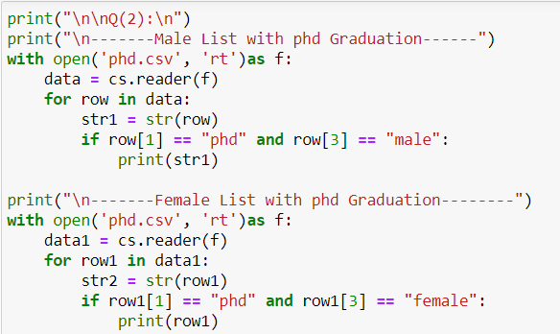

3. Use Salary Gender CSV file. Store the “Age” and “PhD” columns in one Data Frame and delete the data of all people who don’t have a PhD

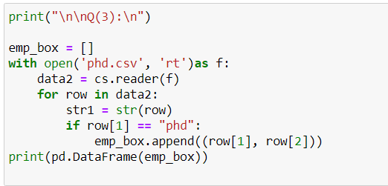

4. Calculate the total number of people who have a PhD degree from SalaryGender CSV file

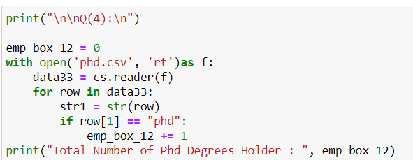

5. How do you Count The Number Of Times Each Value Appears In An Array Of Integers?[0, 5, 4, 0, 4, 4, 3, 0, 0, 5, 2, 1, 1, 9] Answer should be array([4, 2, 1, 1, 3, 2, 0, 0, 0, 1]) which means 0 comes 4 times, 1 comes 2 times, 2 comes 1 time, 3 comes 1 time and so on

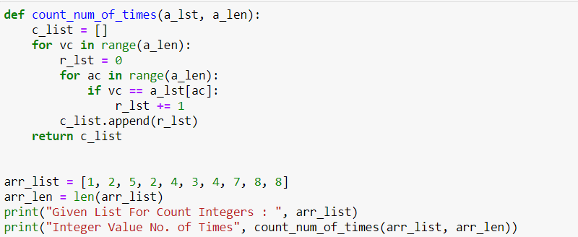

6. Create a numpy array [[0, 1, 2], [ 3, 4, 5],[ 6, 7, 8],[ 9,10, 11]]) and filter the elements greater than 5

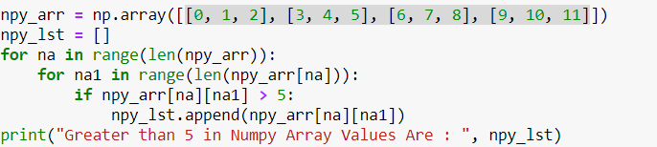

7. Create a numpy array having NaN (Not a Number) and print it

array([ nan, 1., 2., nan, 3., 4., 5.]) Print the same array omitting all elements which are nan

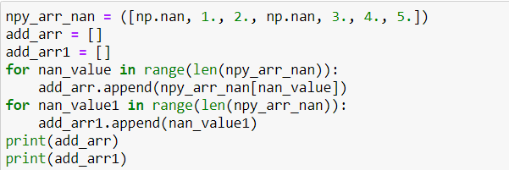

8. Create a 10x10 array with random values and find the minimum and maximum values

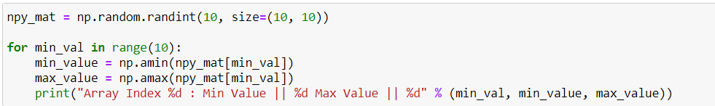

9. Create a random vector of size 30 and find the mean value

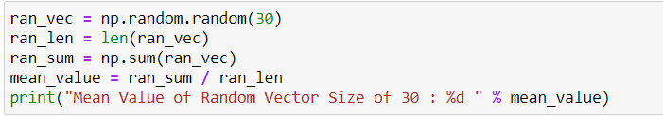

10. Create numpy array having elements 0 to 10 And negate all the elements between 3 and 9

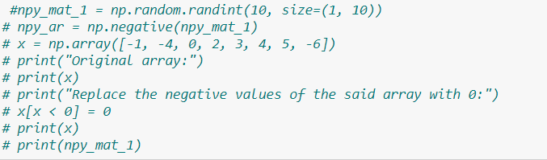

11. Create a random array of 3 rows and 3 columns and sort it according to 1st column, 2nd column or 3rd column

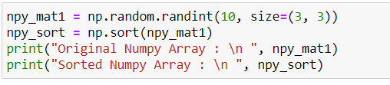

12. Create a four dimensions array get sum over the last two axis at once.

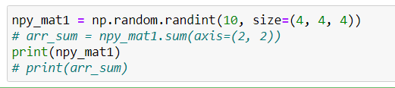

13. Create a random array and swap two rows of an array

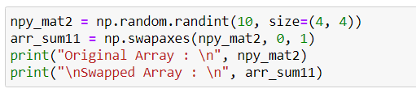

14. Create a random matrix and Compute a matrix rank

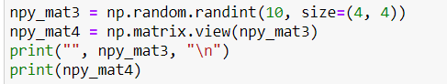

15. Analyse various school outcomes in Tennessee using pandas. Suppose you are a public school administrator. Some schools in your state of Tennessee are performing below average academically. Your superintendent, under pressure from frustrated parents and voters, approached you with the task of understanding why these schools are under performing. To improve school performance, you need to learn more about these schools and their students, just as a business needs to understand its own strengths and weaknesses and its customers. Though you is eager to build an impressive explanatory model, you know the importance of conducting preliminary research to prevent possible pitfalls orblind spots Thus, you engages in a thorough exploratory analysis, which includes: a lit review, data collection, descriptive and inferential statistics, and data visualization.

Phase 1 Data Collection

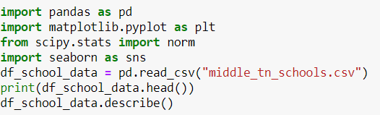

Phase 2 Group data by school ratings



Phase 3 Correlation analysis

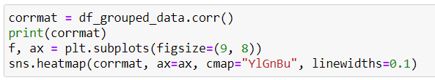

Phase 4 Scatter Plot and Phase 5 Correlation Matrix



